
Event Discovery & Community Engagement Platform
Design Document

Version 1.0



Group Id: S26PROJECT69E8B
Supervisor Name: Amjad Iqbal Khan

Revision History
Date (dd/mm/yyyy) | Version | Description | Author
24/07/2026 | 1.0 | This document contains | bc210403836
 |  | Introduction of Design Document
 |  | Entity Relationship Diagram (ERD)
 |  | Sequence Diagrams
 |  | Architecture Design Diagram
 |  | Class Diagram
 |  | Database Design
 |  | Interface Design
 |  | Test Cases

Table of Contents
Contents
Introduction of Design Document 4
Objectives: 4
Tools & Technology Stack 4
Frontend Technology Stack 4
Backend Technology Stack 5
Primary Users 5
Key Features 5
Entity Relationship Diagram (ERD) 6
Entities & Attributes 6
1. Users 6
2. Events 6
3. Venues 6
4. Categories 7
5. Registrations 7
6. Attendance 7
7. Notifications 7
8. Tags 7
9. Event_Tags (Junction Table) 7
10. Event_Categories (Junction Table) 7
11. Resources 8
12. Event_Resources 8
13. Approvals 8
Relationships 8
Core Relationships 8
Participation & Tracking 8
Resources & Management 8
Approval Workflow 9
Sequence Diagrams 10
Event Filtering & Search 15
Architecture Design Diagram 16
Tiers 16
1. Presentation Layer (Frontend) 16
2. Application Layer (Business Logic Layer) 16
3. Data Layer (Backend / Data Access Layer) 17
Key Notes 17
Class Diagram 19
Database Design 19
Interface Design 20
Test Cases 22
1. Users Entity – Test Cases 22
2. Events Entity – Test Cases 22
3. Venues Entity – Test Cases 22
4. Resources Entity – Test Cases 22
5. Categories Entity – Test Cases 22
6. Registrations Entity – Test Cases 23
7. Approvals Entity – Test Cases 23
8. Attendance Entity – Test Cases 23
9. Notifications Entity – Test Cases 23
10. Tags Entity – Test Cases 23
11. Junction Tables (Event_Tags, Event_Categories, Event_Resources) 23

Introduction of Design Document
This Design Document specifies the architecture, components, interfaces, and data design for the Event Management System web platform. It is intended to guide developers in implementing a secure, user-friendly, and robust event management solution that also supports venue booking and attendance tracking features. The document defines the system’s structure through diagrams and specifications to ensure clarity and alignment with the requirements described in the SRS.

Objectives:
- Define architecture and components.
- Provide visual diagrams (ERD, Class, Architecture).
- Ensure alignment with VU Process Model.
- Serve as a reference during coding, testing, and deployment.

Tools & Technology Stack

Frontend Technology Stack
Component | Technology / Tool
Framework | Next.js 16+ (React-based)
Styling | Tailwind CSS / Styled Components
State Management | Context API / Redux
UI Components | Shadcn/ui / Material-UI
Authentication | NextAuth.js
Map Library | Leaflet.js
Deployment | Vercel / Netlify

Backend Technology Stack
Component | Technology / Tool
CMS | Strapi v5 (Headless CMS)
Database | PostgreSQL / MySQL
Authentication | Strapi built-in auth + JWT
File Storage | Cloudinary / AWS S3
API | RESTful API / GraphQL
Deployment | Railway / DigitalOcean / AWS

The Event Discovery & Community Engagement Platform is a web-based system that allows:
- Guest Users and Registered Users to browse, search, and explore events, view event details, and RSVP or register for events.
- Registered Users to save favorite events, submit reviews and ratings, and manage their profiles and event participation.
- Event Organizers (Registered Users) to submit and manage event listings for approval by the system.
- Administrators to manage events, approve or reject submitted events, manage users and categories, and monitor overall platform activities.
- Integration of interactive maps, event filtering, and automated notifications to enhance event discovery and user engagement.

Primary Users
- Guest User
- Registered User
- Event Organizer
- Administrator (Admin / Super Admin)

Key Features
- Event browsing with interactive map and list view
- Event search and category-based filtering
- Event detail pages with images, location, and full description
- RSVP and event registration system
- Favorite/bookmark events for registered users
- User reviews and ratings for events
- Event submission and approval workflow
- Featured events section on homepage
- Real-time synchronization between map and list views
- Role-based access control (Guest, User, Admin)
- Admin dashboard for event, user, and category management
- Seeded/demo event data for testing and demonstration

Entity Relationship Diagram (ERD)

Entities & Attributes

1. Users
- user_id (PK)
- name
- email
- password_hash
- role
- is_active
- created_at

2. Events
- event_id (PK)
- title
- description
- venue_id (FK)
- category_id (FK)
- start_time
- end_time
- capacity
- status
- organizer_id (FK → Users)
- created_at

3. Venues
- venue_id (PK)
- name
- location
- capacity

4. Categories
- category_id (PK)
- name

5. Registrations
- registration_id (PK)
- user_id (FK)
- event_id (FK)
- status
- registered_at

6. Attendance
- attendance_id (PK)
- registration_id (FK)
- check_in_at

7. Notifications
- notification_id (PK)
- user_id (FK)
- event_id (FK)
- message
- type
- status

8. Tags
- tag_id (PK)
- name

9. Event_Tags (Junction Table)
- id (PK)
- event_id (FK)
- tag_id (FK)

10. Event_Categories (Junction Table)
(if multiple categories allowed)
- id (PK)
- event_id (FK)
- category_id (FK)

11. Resources
- resource_id (PK)
- name
- type
- quantity_available

12. Event_Resources
- id (PK)
- event_id (FK)
- resource_id (FK)
- quantity_reserved

13. Approvals
- approval_id (PK)
- event_id (FK)
- admin_id (FK → Users)
- decision
- reason
- decided_at

Relationships

Core Relationships
- A User organizes → many Events (1:N)
- A User registers for → many Events via Registrations (M:N)
- An Event belongs to → one Venue (N:1)
- An Event belongs to → one or many Categories
- An Event has → many Tags (M:N via Event_Tags)

Participation & Tracking
- A Registration leads to → one Attendance
- A User receives → many Notifications
- An Event generates → many Notifications

Resources & Management
- An Event uses → many Resources (M:N via Event_Resources)

Approval Workflow
- An Event has → approval records in Approvals
- An Admin (User) approves/rejects → events
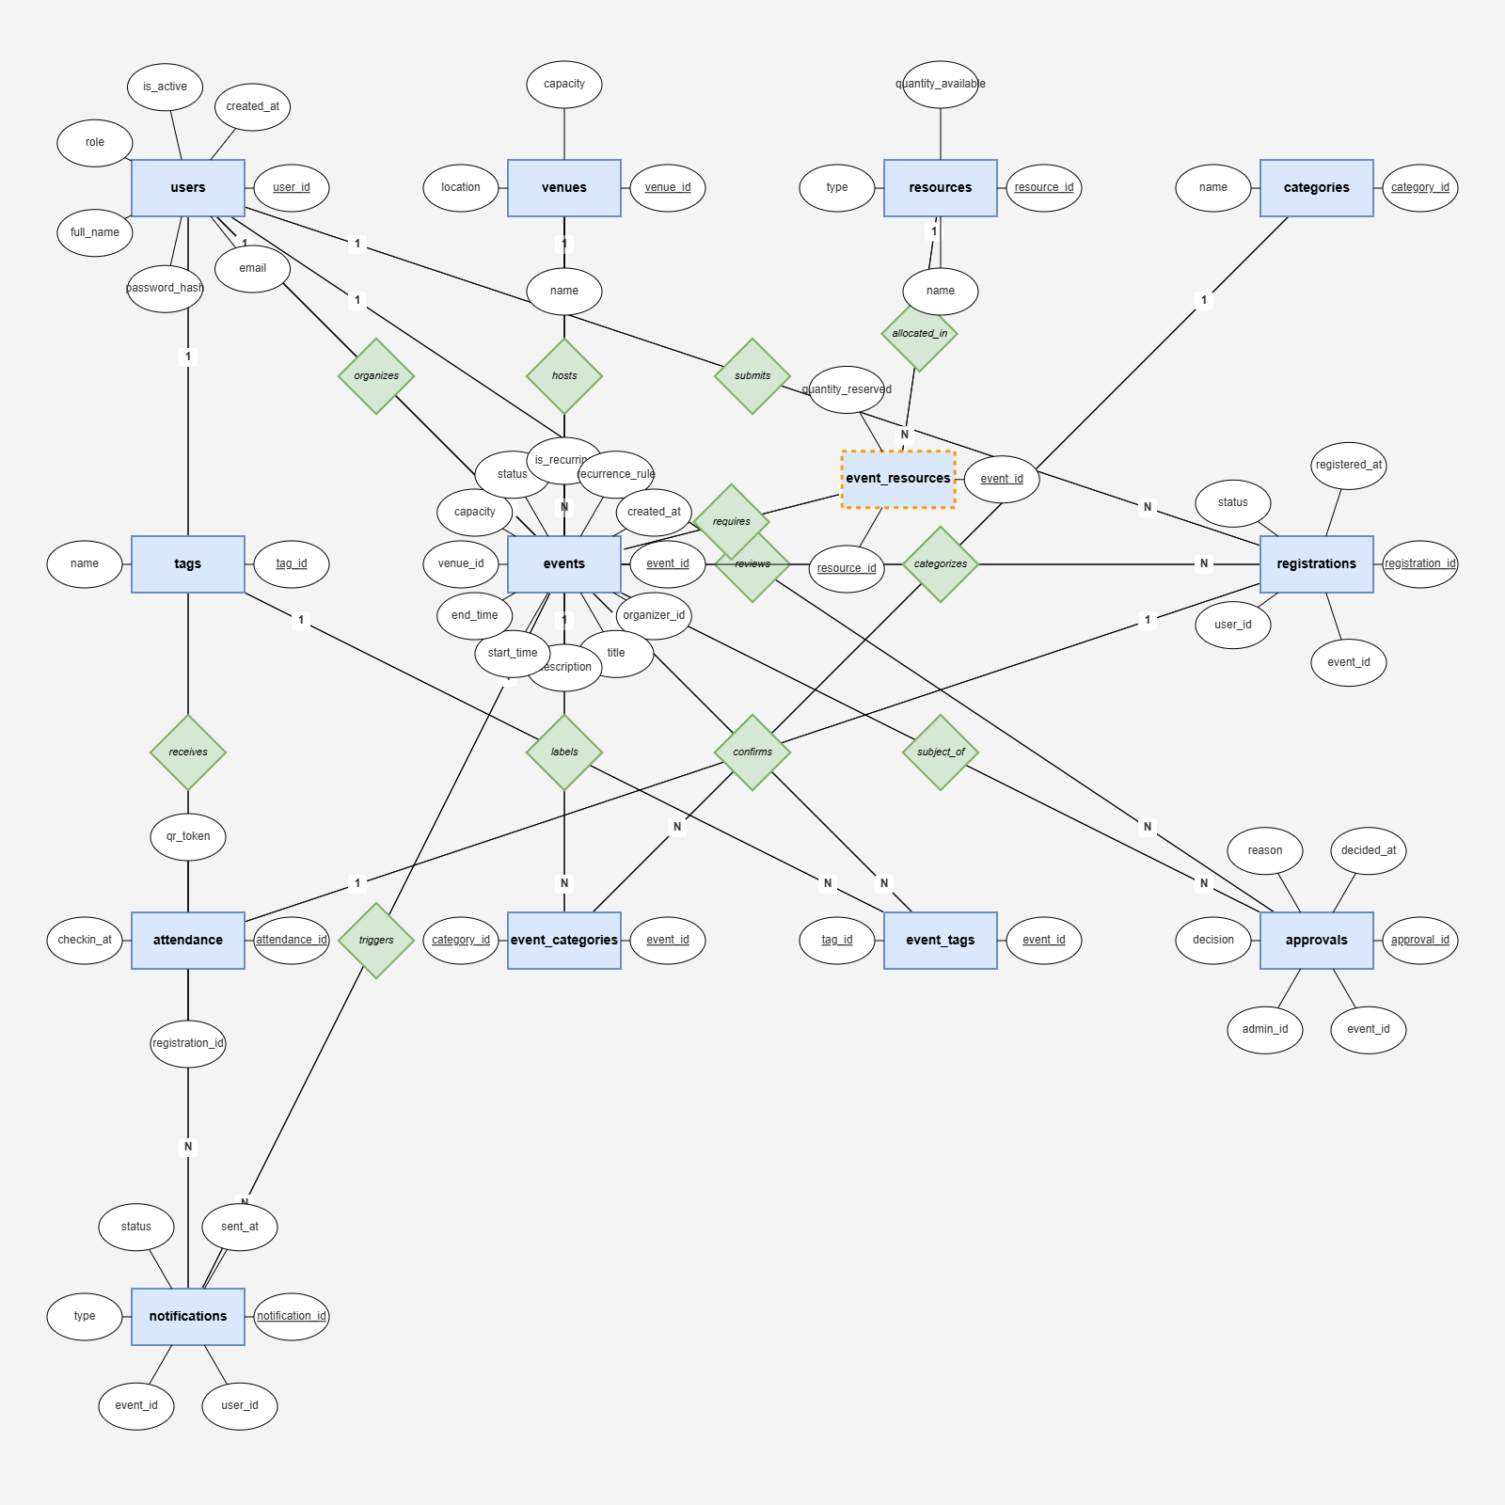

Sequence Diagrams

User Registration
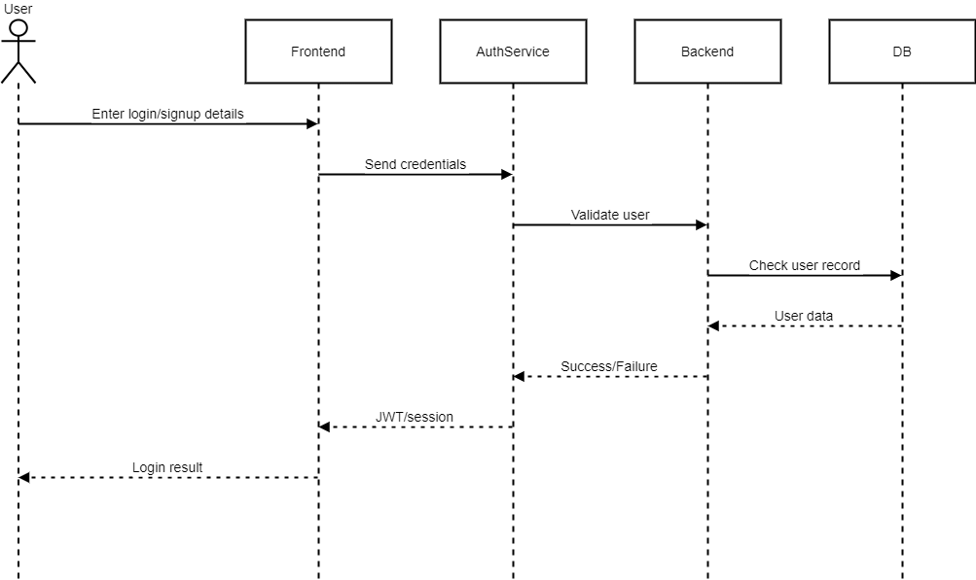Event Browsing
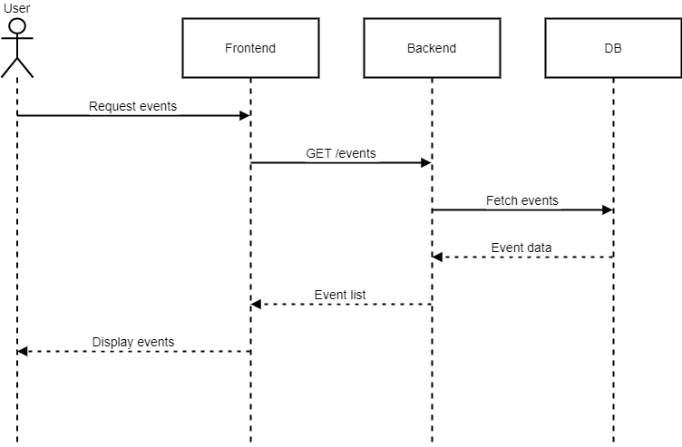
Event Registration (RSVP)
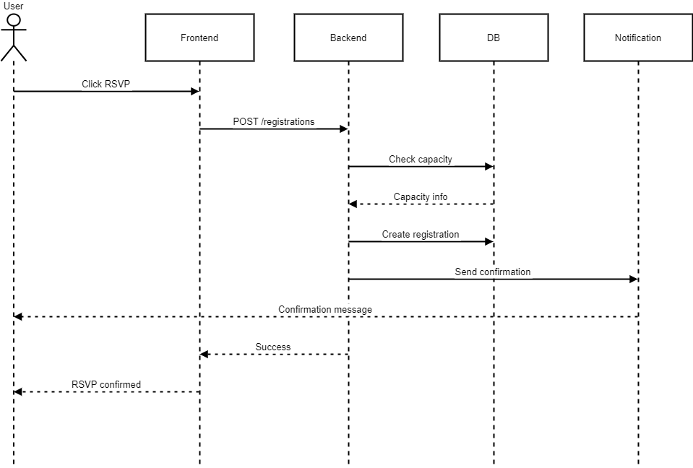
Event Creation (Submission)
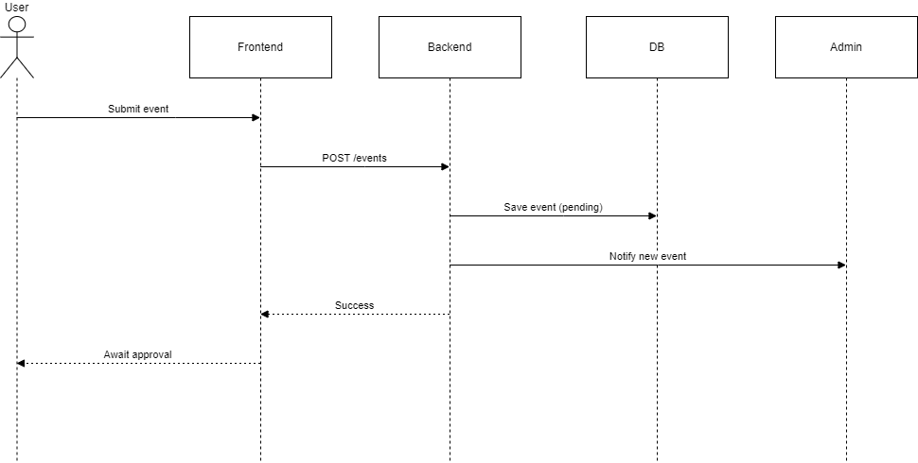
Event Approval (Admin)
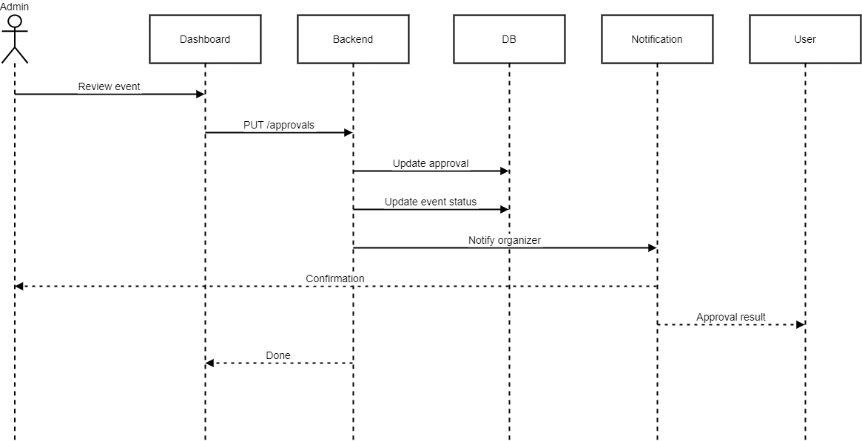

Resource Allocation
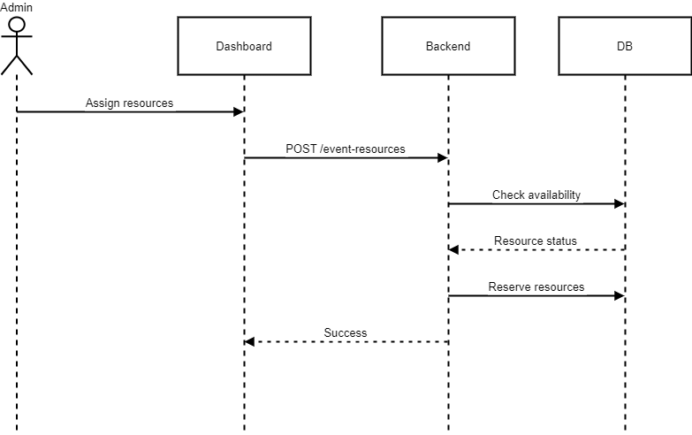

Tag & Category Assignment
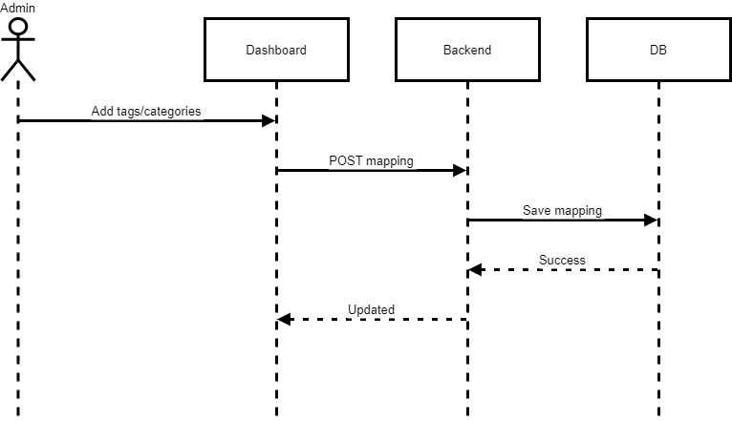

Attendance Tracking
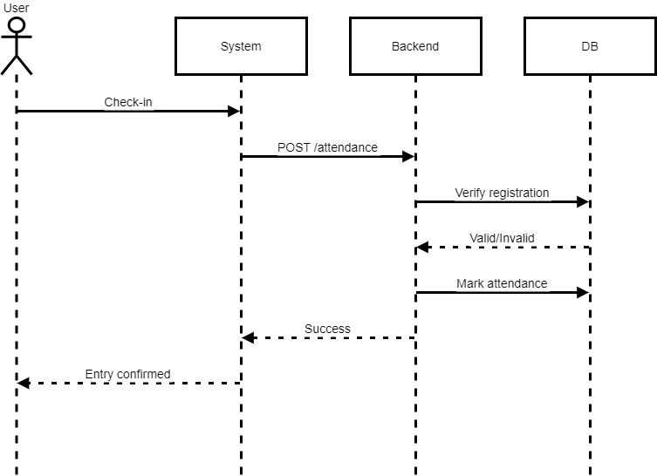

Notifications Flow\
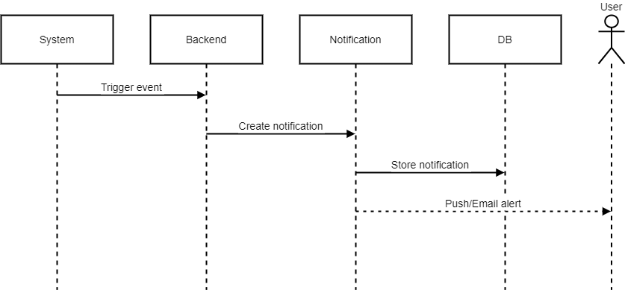

Admin Analytics Dashboard
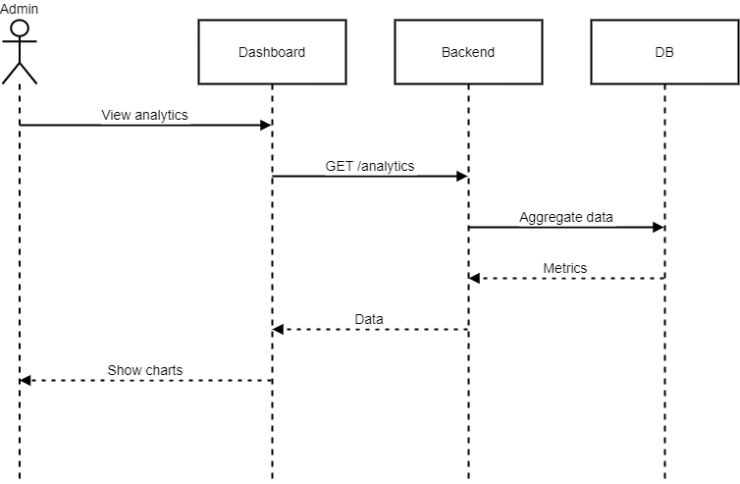

Event Filtering & Search
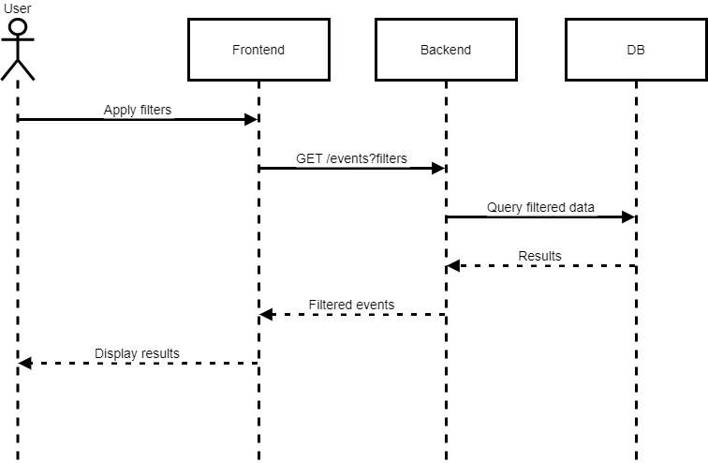

Favorites / Bookmarking
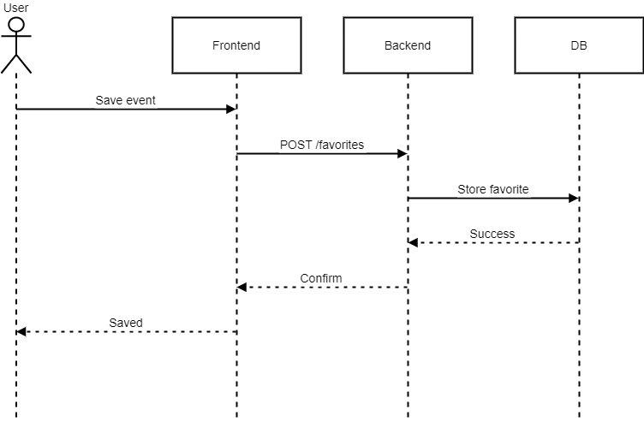

Architecture Design Diagram
3-Tier Architecture (Modern Web Stack)

Tiers

1. Presentation Layer (Frontend)
- Purpose:
Handles user interface, user interactions, and client-side rendering. Provides responsive event browsing, map visualization, and user engagement features.
- Technologies:
  - Next.js (React-based framework)
  - Tailwind CSS / Styled Components
  - Shadcn UI / Material-UI
  - Leaflet.js (for maps)
  - NextAuth.js (authentication handling)

2. Application Layer (Business Logic Layer)
- Purpose:
Manages core application logic, workflows, authentication, authorization, and API handling. Processes event submissions, approvals, RSVPs, and user-specific operations.
- Technologies:
  - Strapi v5 (Headless CMS)
  - Custom Controllers & Services (Strapi APIs)
  - JWT-based Authentication
  - RESTful API / GraphQL API

3. Data Layer (Backend / Data Access Layer)
- Purpose:
Handles data storage, retrieval, and persistence. Ensures efficient querying and management of events, users, registrations, and related entities.
- Technologies:
  - PostgreSQL / MySQL (Database)
  - Strapi ORM / Query Engine
  - Cloud Storage (AWS S3 / Cloudinary for media files)

Key Notes
- Clear separation of concerns between UI, logic, and data
- Scalable headless architecture using Next.js + Strapi
- Secure authentication and role-based access control
- API-driven communication between frontend and backend
- Optimized for performance, SEO, and responsiveness

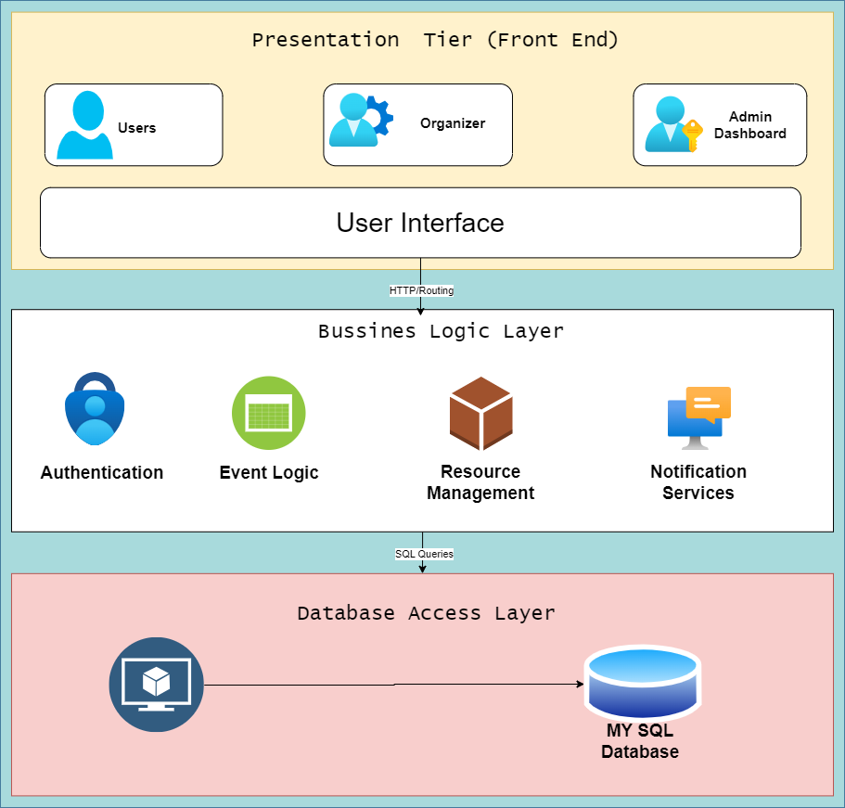

Class Diagram
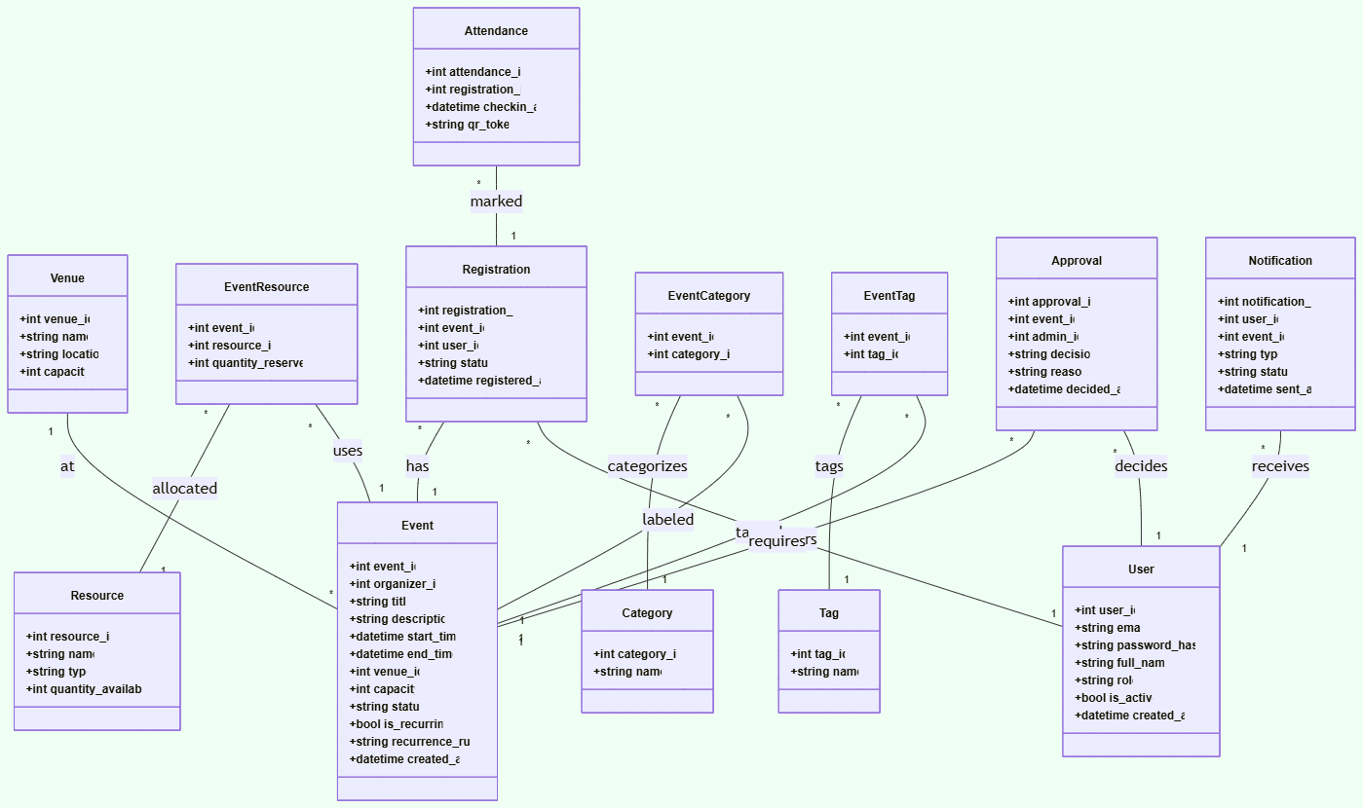

Database Design
The Database Design defines how data will be structured, stored, and accessed in your system. Based on the ERD and Class Diagram, we’ll now define the:
- Tables
- Fields (with data types)
- Primary & Foreign Keys
- Relationships
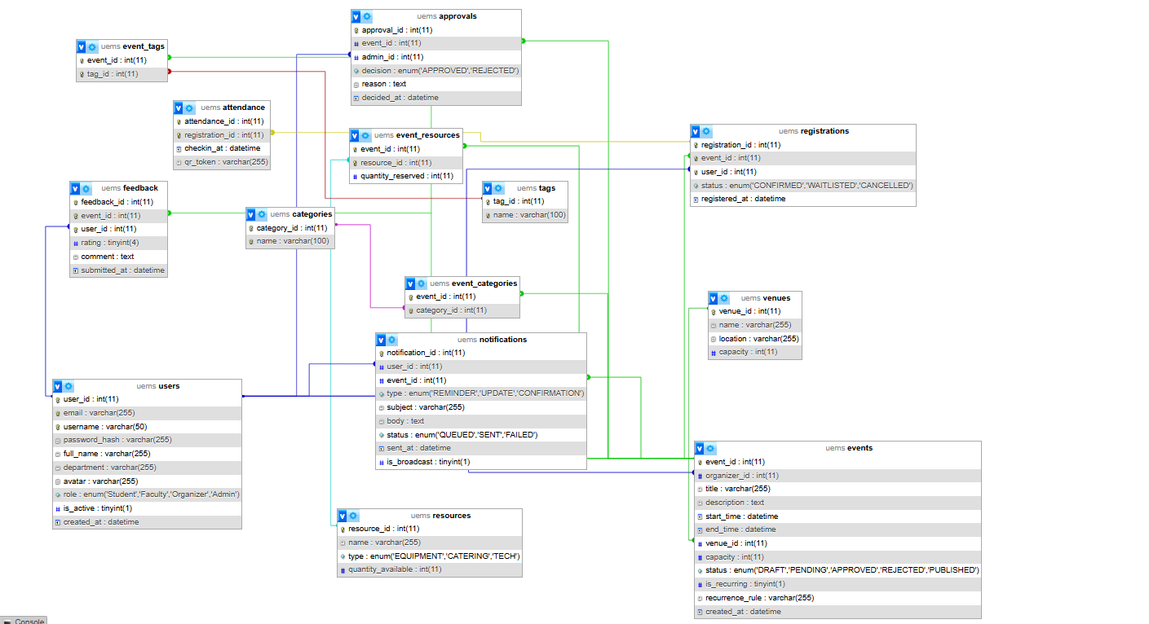

Interface Design

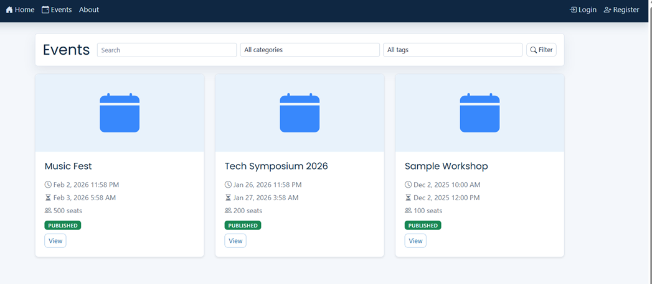

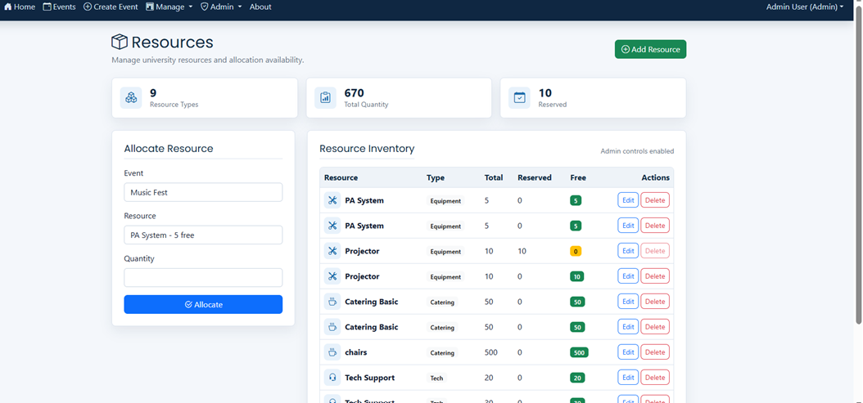
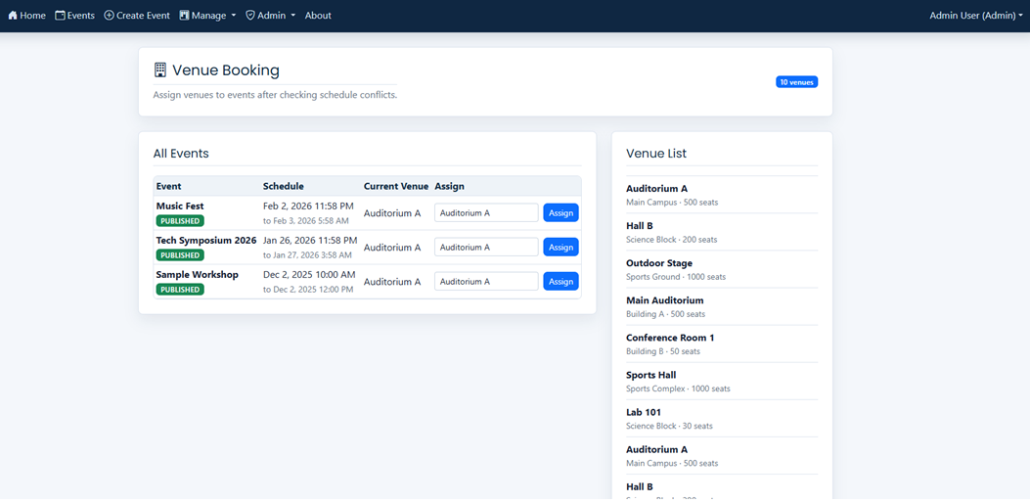
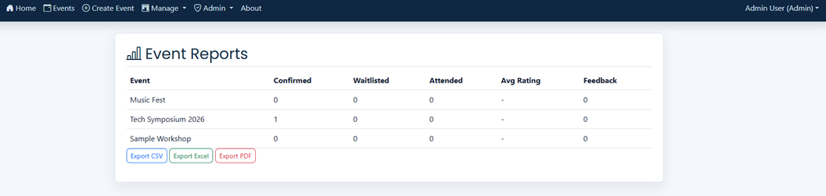

Test Cases

1. Users Entity – Test Cases
Test Case ID | Test Scenario | Input | Expected Output | Status
TC_USER_01 | Register new user | Valid name, email, password | User account created successfully | Pass
TC_USER_02 | Register with existing email | Duplicate email | Error: Email already exists | Pass
TC_USER_03 | Login with valid credentials | Correct email & password | User logged in | Pass
TC_USER_04 | Login with invalid password | Wrong password | Error message displayed | Pass
TC_USER_05 | Update profile | New name/email | Profile updated | Pass

2. Events Entity – Test Cases
Test Case ID | Test Scenario | Input | Expected Output | Status
TC_EVENT_01 | Create event | Valid event details | Event created successfully | Pass
TC_EVENT_02 | Create event with missing fields | Missing title/date | Validation error | Pass
TC_EVENT_03 | Update event | Modified details | Event updated | Pass
TC_EVENT_04 | Delete event | Valid event ID | Event removed | Pass
TC_EVENT_05 | View event details | Event ID | Event info displayed | Pass

3. Venues Entity – Test Cases
Test Case ID | Test Scenario | Input | Expected Output | Status
TC_VENUE_01 | Add venue | Valid venue data | Venue added | Pass
TC_VENUE_02 | Assign venue to event | Venue ID + Event ID | Venue linked to event | Pass
TC_VENUE_03 | Check capacity limit | Over-capacity booking | Error: Capacity exceeded | Pass

4. Resources Entity – Test Cases
Test Case ID | Test Scenario | Input | Expected Output | Status
TC_RES_01 | Add resource | Resource name/type | Resource added | Pass
TC_RES_02 | Allocate resource to event | Resource ID + Event ID | Resource assigned | Pass
TC_RES_03 | Allocate unavailable resource | Already allocated | Error: Not available | Pass

5. Categories Entity – Test Cases
Test Case ID | Test Scenario | Input | Expected Output | Status
TC_CAT_01 | Add category | Category name | Category created | Pass
TC_CAT_02 | Assign category to event | Category ID + Event ID | Category linked | Pass
TC_CAT_03 | Duplicate category | Same name | Error message | Pass

6. Registrations Entity – Test Cases
Test Case ID | Test Scenario | Input | Expected Output | Status
TC_REG_01 | Register for event | User ID + Event ID | Registration successful | Pass
TC_REG_02 | Duplicate registration | Same user/event | Error: Already registered | Pass
TC_REG_03 | Cancel registration | Registration ID | Registration removed | Pass

7. Approvals Entity – Test Cases
Test Case ID | Test Scenario | Input | Expected Output | Status
TC_APP_01 | Approve event | Admin decision = Approve | Event approved | Pass
TC_APP_02 | Reject event | Admin decision = Reject | Event rejected | Pass
TC_APP_03 | Invalid approval action | Missing decision | Error message | Pass

8. Attendance Entity – Test Cases
Test Case ID | Test Scenario | Input | Expected Output | Status
TC_ATT_01 | Mark attendance | Valid check-in token | Attendance recorded | Pass
TC_ATT_02 | Invalid token | Wrong token | Error message | Pass
TC_ATT_03 | Duplicate check-in | Same token reused | Error: Already checked-in | Pass

9. Notifications Entity – Test Cases
Test Case ID | Test Scenario | Input | Expected Output | Status
TC_NOTIF_01 | Send notification | Event update | Notification sent to users | Pass
TC_NOTIF_02 | Notify registration success | User registers | Confirmation notification | Pass
TC_NOTIF_03 | Invalid user ID | Wrong user | Notification fails | Pass

10. Tags Entity – Test Cases
Test Case ID | Test Scenario | Input | Expected Output | Status
TC_TAG_01 | Create tag | Tag name | Tag added | Pass
TC_TAG_02 | Assign tag to event | Tag ID + Event ID | Tag linked | Pass
TC_TAG_03 | Duplicate tag | Same name | Error message | Pass

11. Junction Tables (Event_Tags, Event_Categories, Event_Resources)
Test Case ID | Test Scenario | Input | Expected Output | Status
TC_JUNC_01 | Link event & tag | Event ID + Tag ID | Relation created | Pass
TC_JUNC_02 | Link event & category | Event ID + Category ID | Relation created | Pass
TC_JUNC_03 | Remove relation | IDs | Relation deleted | Pass

